Name: ________________________________ Date: ___________________________________

Class: _________________________________ Teacher: ___________________________________

# Math Mini Quiz 2

This Mini Quiz, we’re going to explore the math concepts that you’ve learned so far in this unit. This assignment should take you about **25 minutes**.

### Part 1 Jet Skis and Speedboats

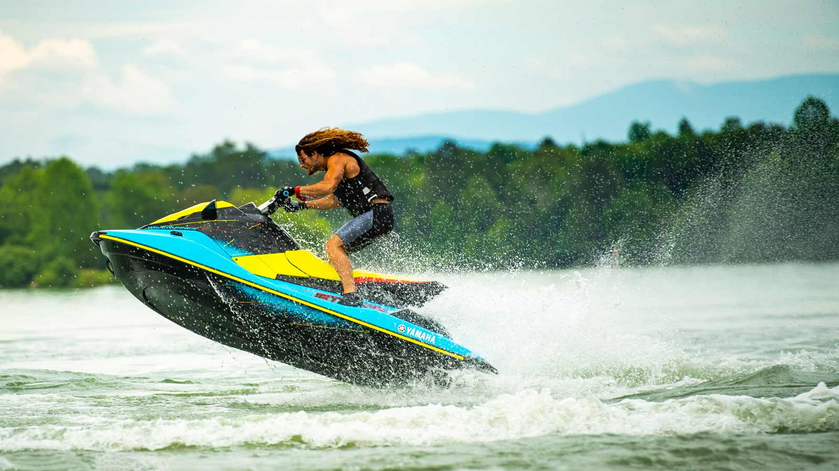

You are running a water sports center. Two of your most popular activities are the jetskis and the speedboat. However, to reduce the company’s carbon footprint, you’ve limited your company to 80 gallons of fuel per day. Each ride on the jetski (1 person) costs 8 gallons. Each speedboat ride (4 people) uses 20 gallons. The jetski and the speedboat trips take the same amount of time.

1) Express your constraint on fuel using ***j***, the number of jet ski rides, and ***s***, the number of speedboat rides.

2) On Monday morning, you have 4 jet ski rides scheduled. The rest of the day will be all speedboat rides. How many speed boat rides can you do on Monday?

3)You realize you forgot to write down how many of each ride were bought today.. However, you check the number of waivers, and you find out you had 7 customers. You also know that you used exactly 80 gallons of fuel today. How many of each ride did you do today?

### Part 2 Graph Analysis

You’re on the varsity softball team. You’re at an away game and someone on your school’s baseball team comes to you and says they forgot to fill their water cooler! You tell them not to worry because you’re happy to share some of your water. You tell them to open the top of their cooler, which already had some water in it, and you start pouring some water into their cooler. As you pour, below are the graphs of the water in each cooler over time.

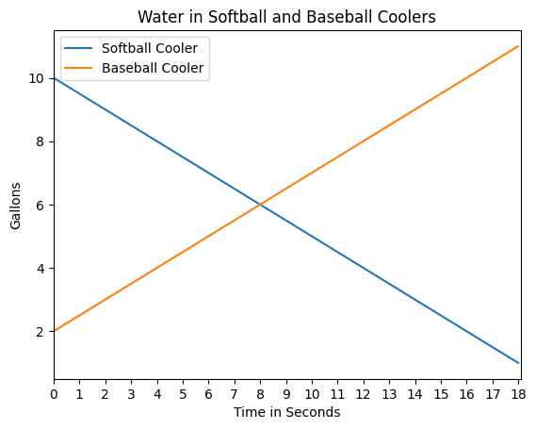

4) At what time do the coolers have an equal amount of water? How do you know?

5) If each cooler has a capacity of 10 gallons, will the baseball team water cooler overflow or will the softball team run out of water first?

6) Decide how much water you would give to the baseball team (more than 0), and determine how long you should let the water flow from your cooler to theirs.